SOLID
--------
Single Responsibility Principle (SRP)
- responsibility to a separate class and methods that can be maintained and updated independently
Open/Closed Principle (OCP)
- being able to change the behavior of a method or class without having to modify the code.
- You can introduce new implementations by passing them as an argument without modifying the body of this method.
- Hence, it is now open for extension and closed for modification.
- This reduces the scope for introducing new bugs because it minimizes cascading changes required to parts of code that have already been implemented and tested.
- In other words, old code still works and is untouched.
Liskov Substitution Principle (LSP)
- Preconditions cannot be strengthened in a subtype
For example, all our Importer implementations have the precondition that the file being imported exists and is readable. As a result, the importFile method has validation code before any Importer is invoked
- Postconditions cannot be weakened in a subtype
- Postconditions are things that have to be true after some code has run.
- So if the parent has some kind of side effect or returns some value, then the child must do so as well.
- For example, after importFile() has run, if the file in question is valid it must be in the list of documents returned by contents()
- Invariants of the supertype must be preserved in a subtype
- An invariant is something that never changes
- we want to make sure that any invariants that are expected to be maintained by the parent class should also be maintained by the children
- The History Rule
- the child class shouldn’t allow state changes that your parent disallowed.
- So, in our The Document Management System program we have an immutable Document class. In other words, once it has been instantiated you can’t remove, add, or alter any of the attributes.
- You shouldn’t subclass this Document class and create a mutable Document class.
- This is because any user of the parent class would expect certain behavior in response to calling methods on the Document class. If the child were mutable, it could violate callers’ expectations about what calling those methods does.

Interface Segregation Principle (ISP)
- It makes the case that no class should be forced to depend on methods it does not use because this introduces unnecessary coupling
- The ISP focuses on the user of an interface rather than its design.
- In other words, if an interface ends up very large, it may be that the user of that interface sees some behaviors it doesn’t care for, which causes unnecessary coupling.
- To provide a solution that meets the Interface Segregation Principle, we are encour‐ aged to separate out concepts in smaller interface that can evolve separately. This idea essentially promotes higher cohesion.

Dependency Inversion Principle (DIP)

KISS
- You can “Keep It Short and Simple” (KISS) and have the application code in one single class
code maintainability
- It should be simple to locate code responsible for a particular feature.
- It should be simple to understand what the code does.
- It should be simple to add or remove a new feature.
- It should provide good encapsulation. In other words, implementation details should be hidden from a user of your code so it is easier to understand and make changes.
Avoid Code Duplication
Cohesion
- how strongly related responsibilities of a class or method are
- high cohesion, which means that the code is easier for others to locate, understand, and use
- class BankTransactionCSVParser is highly cohesive. In fact, it groups together two methods that are related to parsing CSV data.
Class-Level Cohesion
- Functional
- group the methods functionally
- This is generally a good way to achieve high cohesion because the methods are working together
- The danger with functional cohesion is that it may be tempting to have a profusion of overly simplistic classes grouping only a single method.
- Going down the road of overly simplistic classes adds unnecessary verbosity and complexity because there are many more classes to think about.
- Informational
- work on the same data or domain object
- Ex: CRUD operations
- The downside of this approach is that this kind of cohesion can group multiple concerns together,
- which introduces additional dependencies for a class that only uses and requires some of the operations.
- Utility
- group different unrelated methods inside a class
- This hap‐pens when it is not obvious where the methods belong so you end up with a utility class that is a bit like a jack of all trades.
- Logical
- In fact, the methods are logically categorized to do “parsing.” Ex: CSV, JSON, and XML.
- However, they are different by nature and each of the methods would be unrelated. Grouping them would also break the SRP

- Sequential
- grouping the methods so that they follow a sequence of input to output
- EX: read a file, parse it, process it, and save the information
- AVOID -> breaking the SRP
- Temporal
- performs several operations that are only related in time
- e.g., connecting and closing a database connection
- The initialization and the other operations are unrelated, but they have to be called in a specific order in time

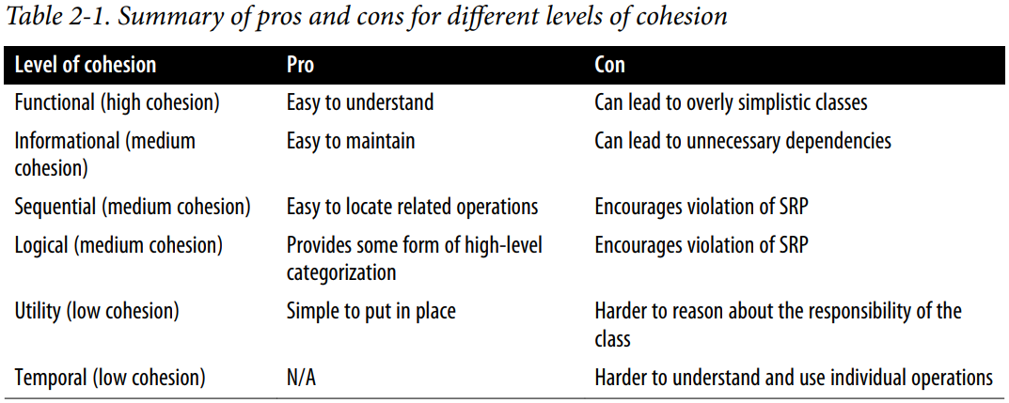
Coupling
- how dependent you are on other classes
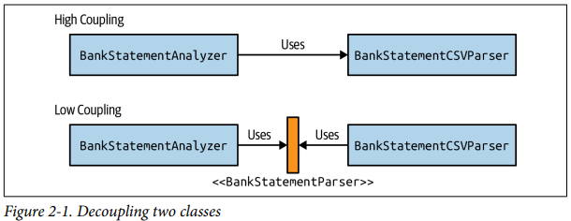

TDD
- One good first step to approaching any program is to start with test-driven development (TDD)
Test Hygiene
- Test hygiene means to keep your test code clean and ensure that it is main‐ tained and improved along with your codebase under test.
Builder Pattern
- The Builder pattern essentially deconstructs the parameters of a constructor and instead provides methods to supply each of the parameters.
- The benefit of this approach is that it allows you to declare methods with names that are suitable to the domain at hand

